NIKKEI Turntables Photo Instructions
All photos must be taken off the fully installed product:
- Placed NIKKEI Slip Mat
- Mounted headpiece
- Mounted hood

NTT01U
Current pictures:
Picture 1: Front perspective at 40 degrees with open hood + mounted headpiece
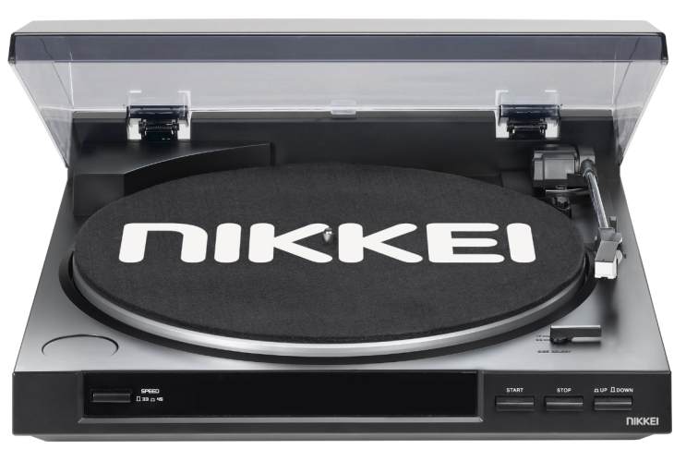
Picture 2: Front left perspective 40 degrees with open hood + mounted headpiece
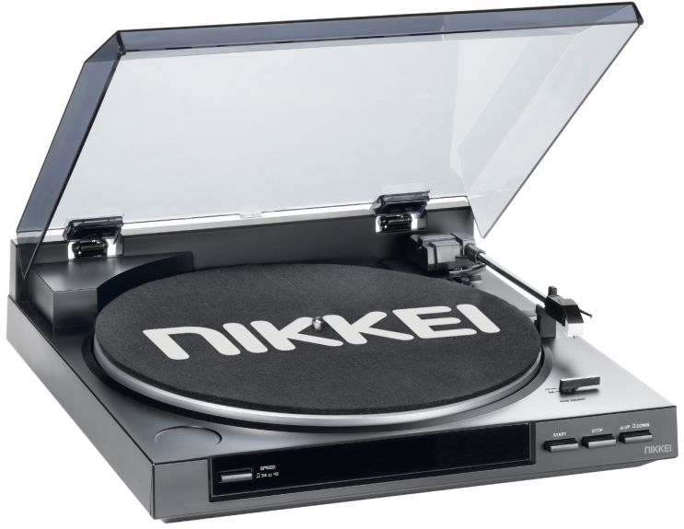

Picture 3: Front right perspective 40 degrees with closed hood+ mounted headpiece
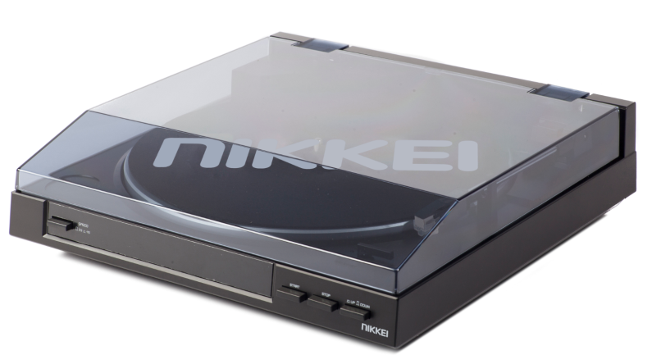
Picture 4: Front right perspective 40 degrees close-up on headpiece and switches
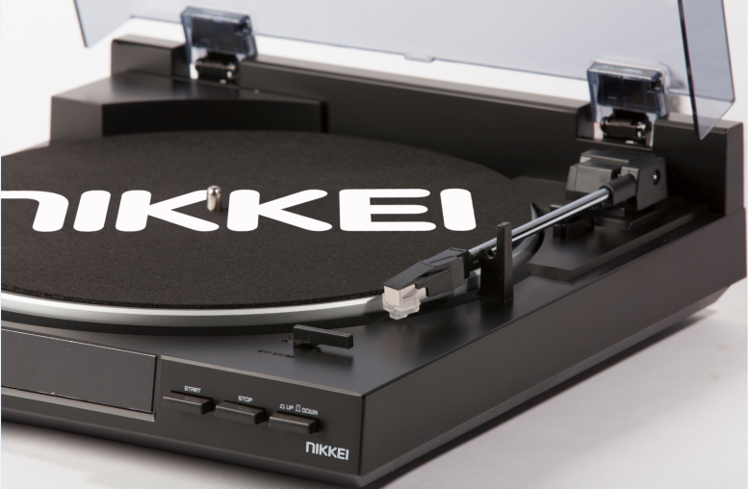
Picture 5: Front right perspective 40 degrees with fully opened hood and mounted headpiece
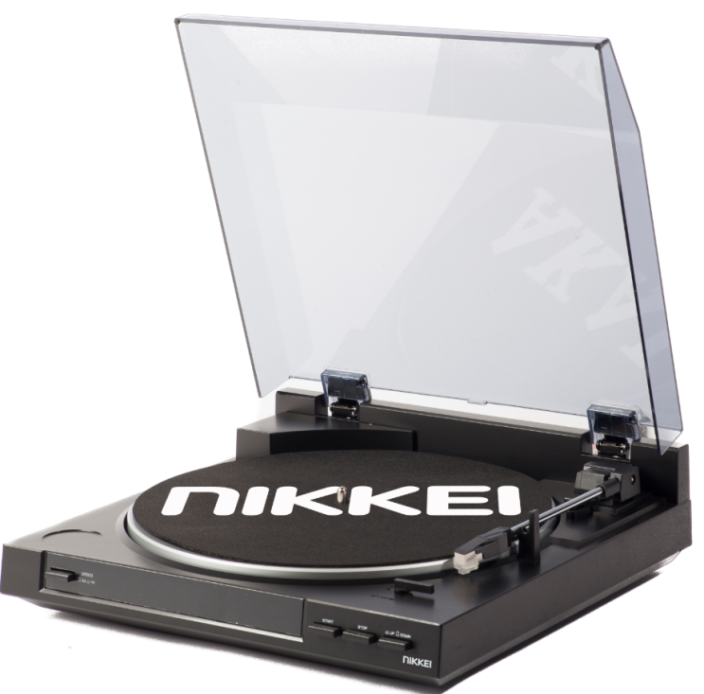

Picture 6: Front right perspective 40 degrees close-up on headpiece
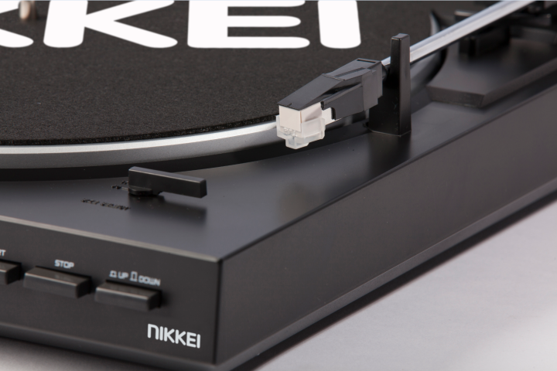
Picture7: Front right perspective 40 degrees close-up on front right
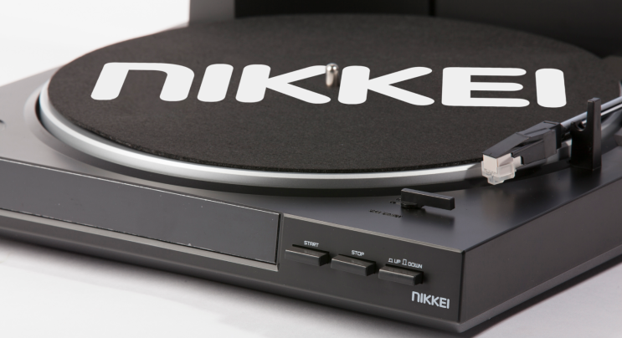

Missing pictures NTT01U:
- Top view picture
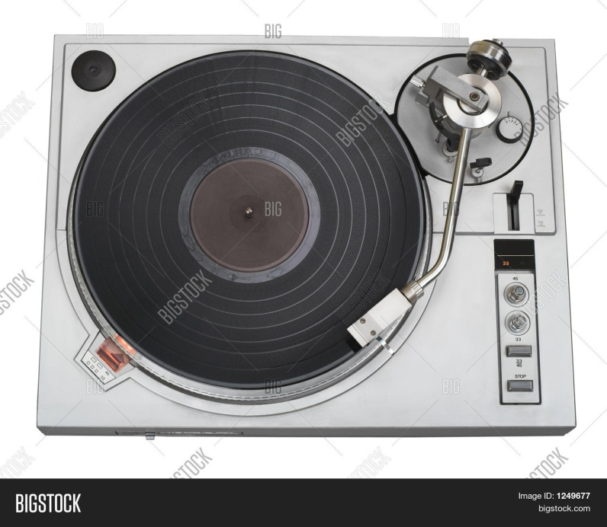

- (In use picture)
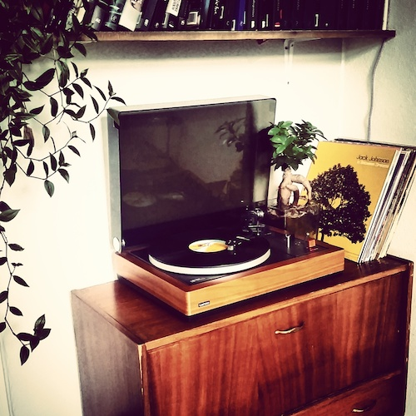

NTT05U
Current pictures:
Picture 1: Front perspective 40 degrees with open hood, mounted headpiece (place don slipmat. Must be changed because doesn’t make any sense)
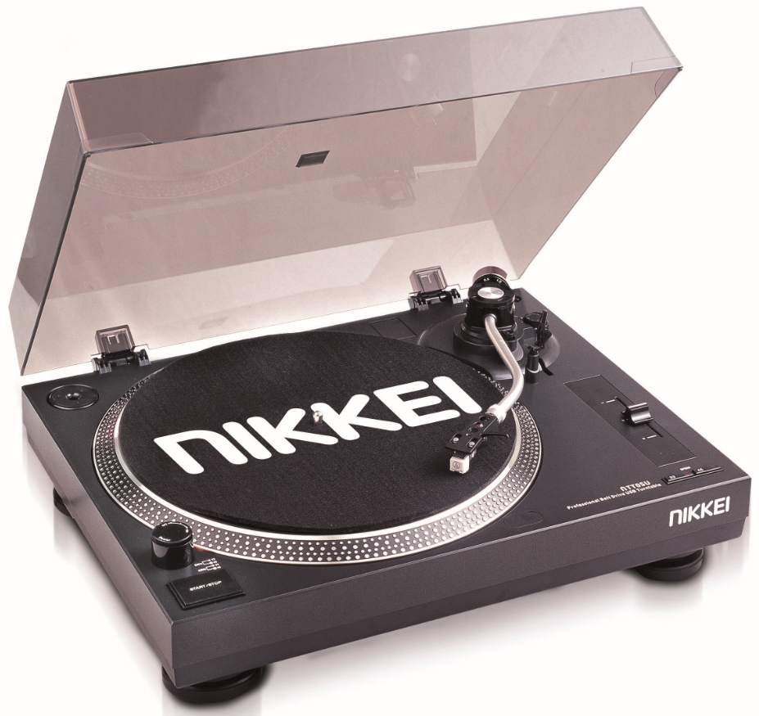
Picture 2: Front view perspective 40 degrees with open hood and missing mounted headpiece
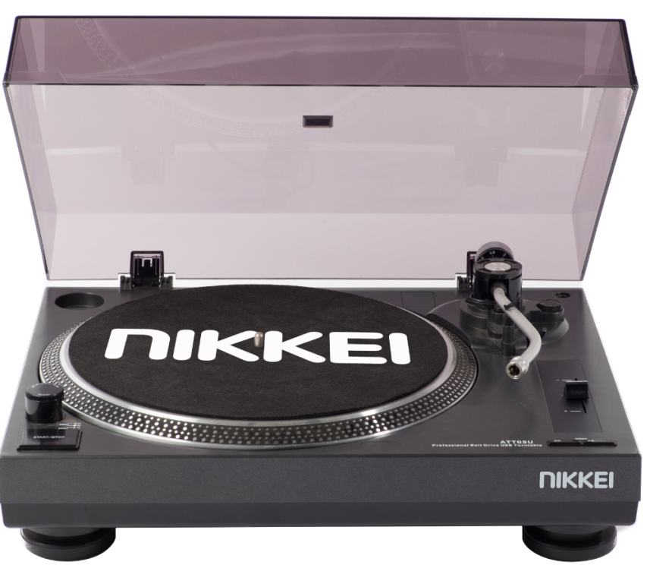

Picture 3: Front perspective at 40 degrees with open hood + placed l.p. (missing mounted headpiece!!)
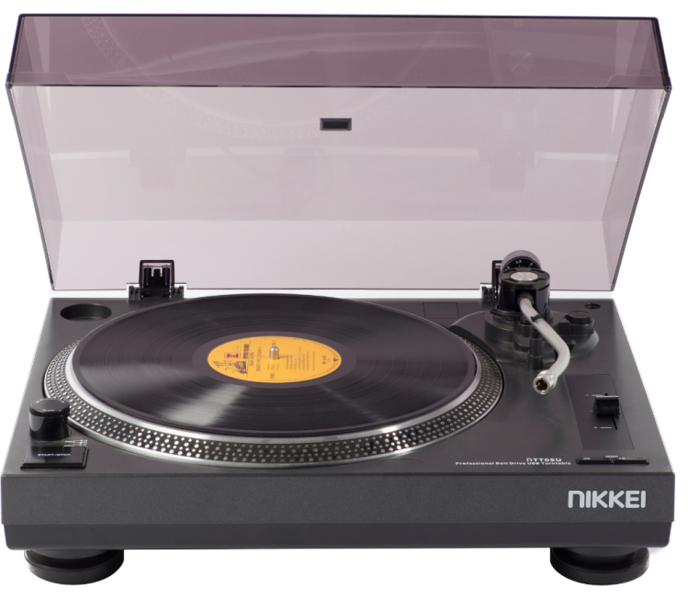
Picture 4: Front right perspective 40 degrees with closed hood
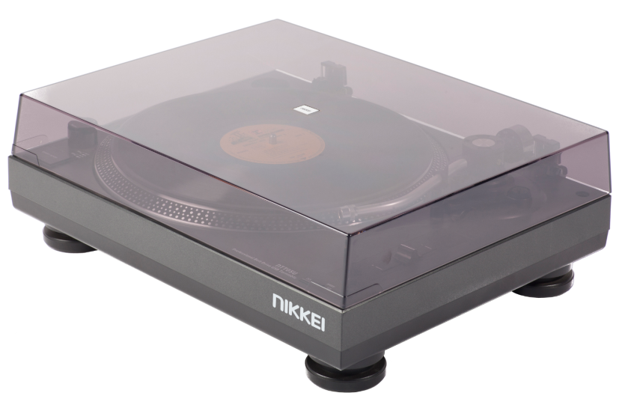

Picture 5: Front right perspective 40 degrees with open hood and place l.p. (headpiece is not mounted!, must be changed)
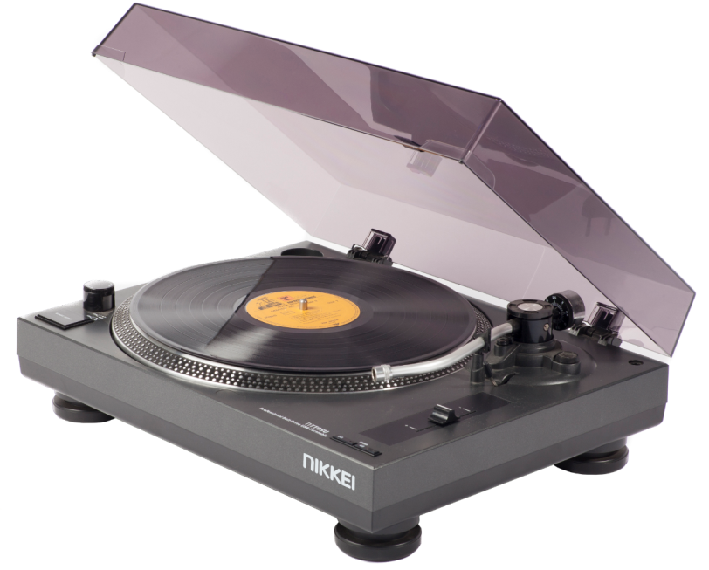
Picture 6: Front right perspective unknown angle, close up. This photo is not usefull and must be removed
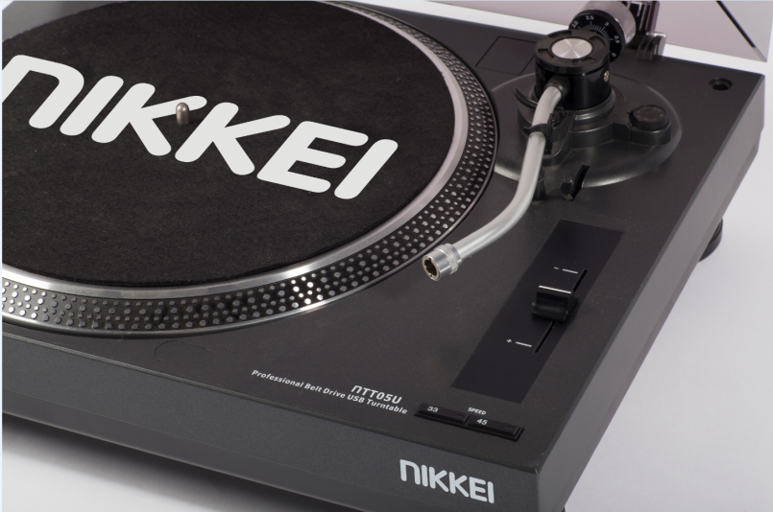
Picture 7: Front left perspective, close up on start/stop button (not sure it this picture is usefull)
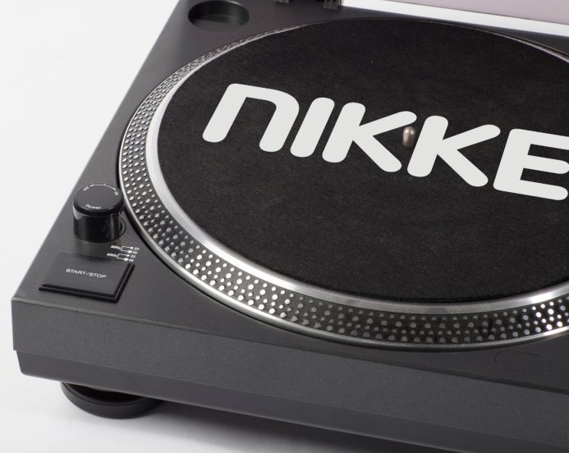
Missing pictures NTT05U:
- Top view picture
- Detailed animation about USB encoding
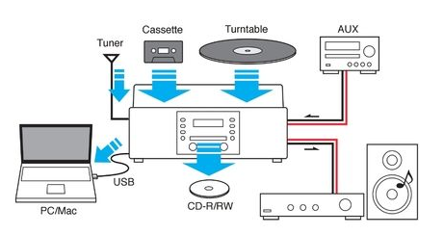

- (In use picture)

NTT15U
Current pictures:
Picture 1: Front left perspective 40 degrees with open hood + mounted headpiece
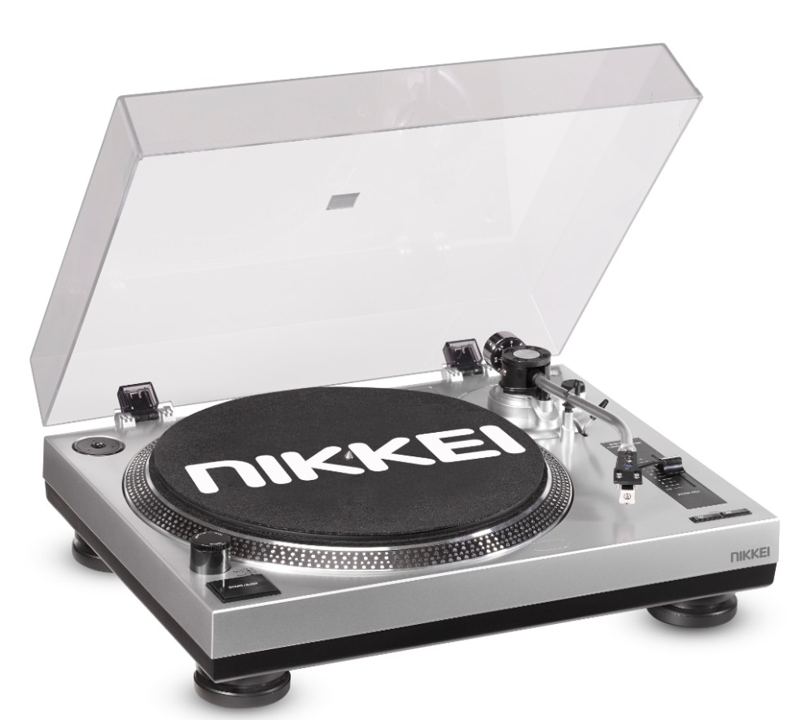

Picture 2: Front right perspective 40 degrees with closed hood+ mounted headpiece
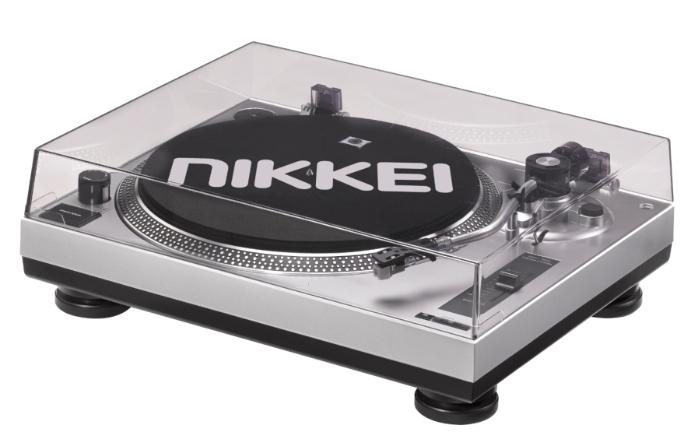

Picture 3: Front right perspective 40 degrees with hood fully open+ mounted headpiece
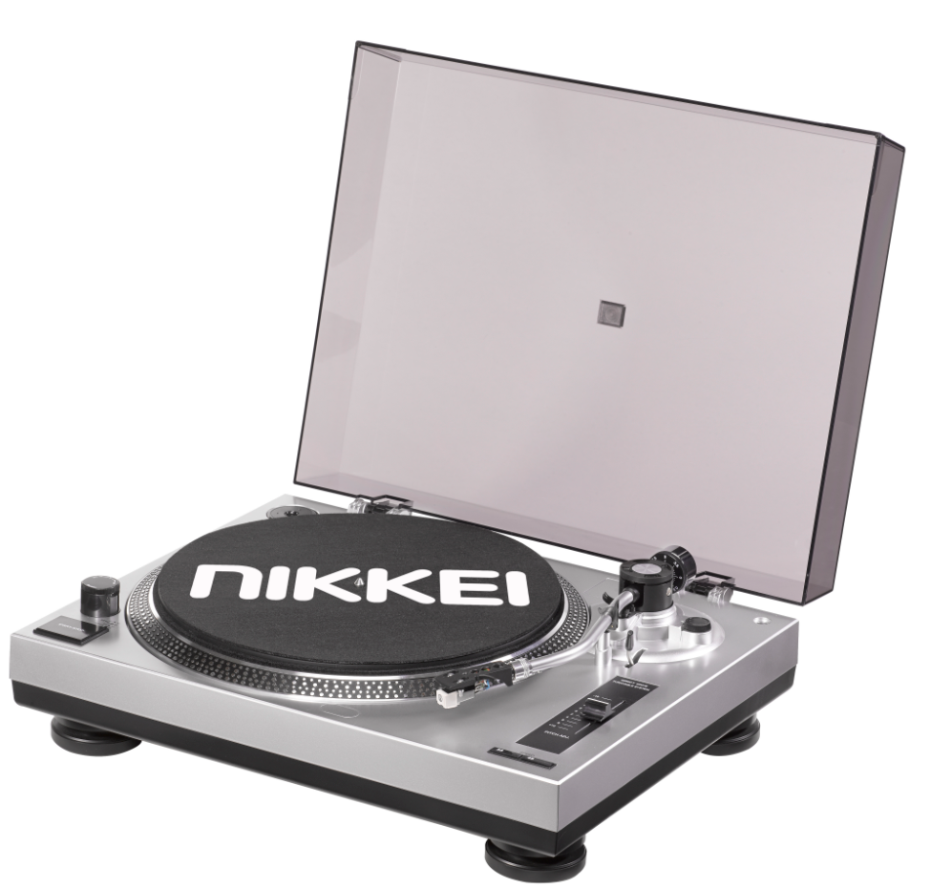

Picture 4: Back view with closed hood were the portals are shown
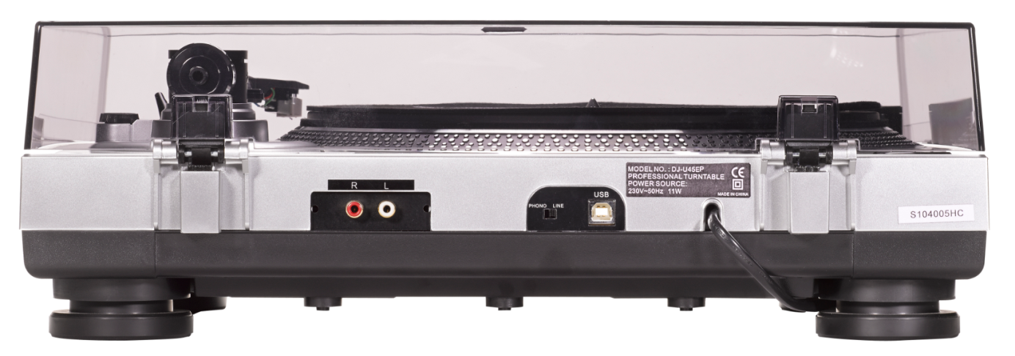

Picture 5: Detailed photo of the tone arm and detachable head piece

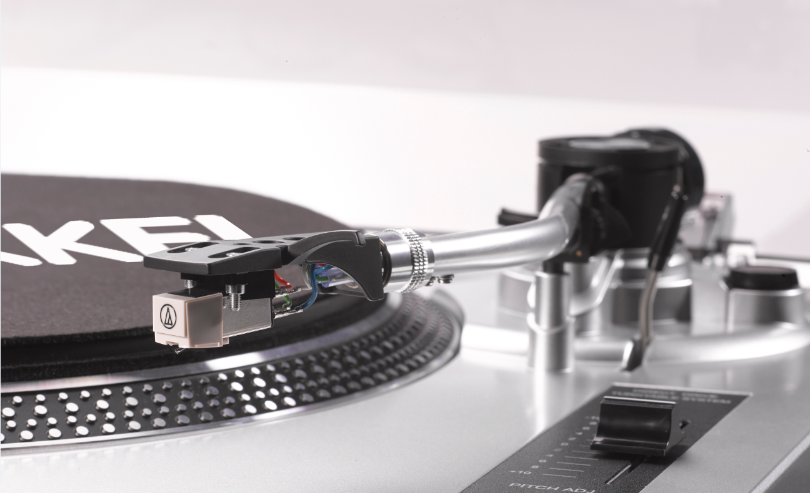
Missing pictures NTT15U:
- Top view picture

- Front view picture at 40 degrees with open hood+ mounted headpiece (like ATT01)
- Detailed animation about USB encoding

- (In use picture)

