NPRC60PK Boombox
Picture 1: Front right perspective 40 degrees with carrying handle up and telescopic antenna up. Display must be on and on FM106.40
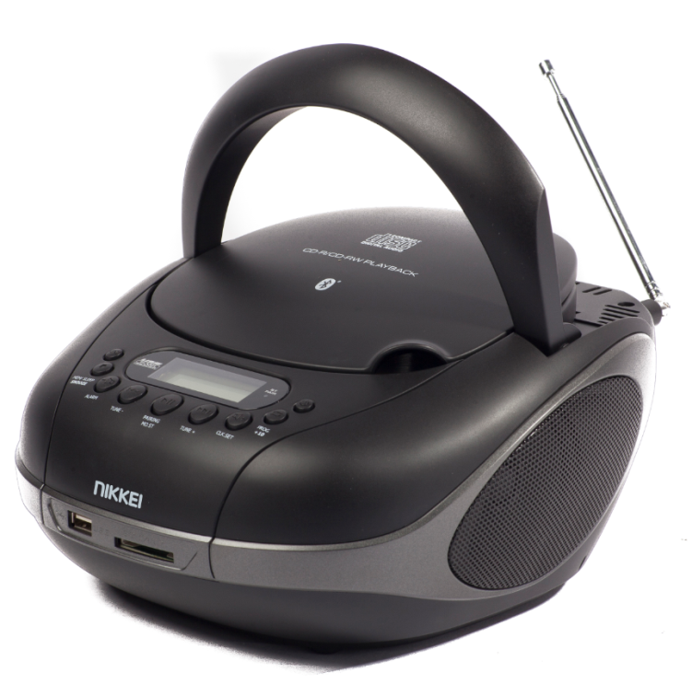

Picture 2: Front left perspective with carrying handle and antenna down. Display must be on and on FM106.40
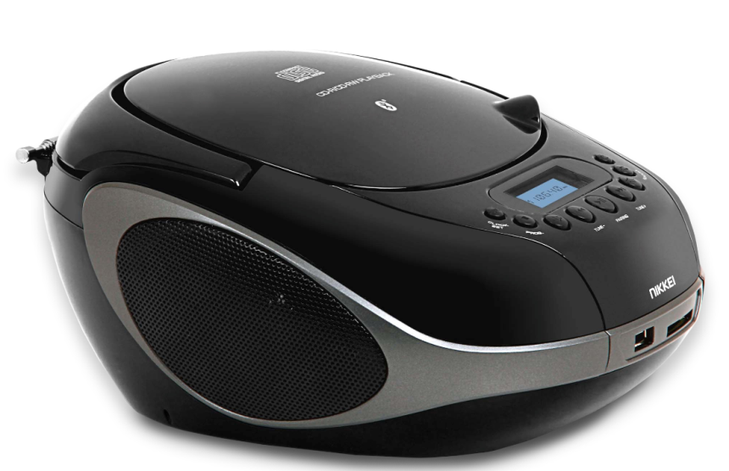

Picture 3: Front view 40 degrees with display on and frequency set on FM 106.40
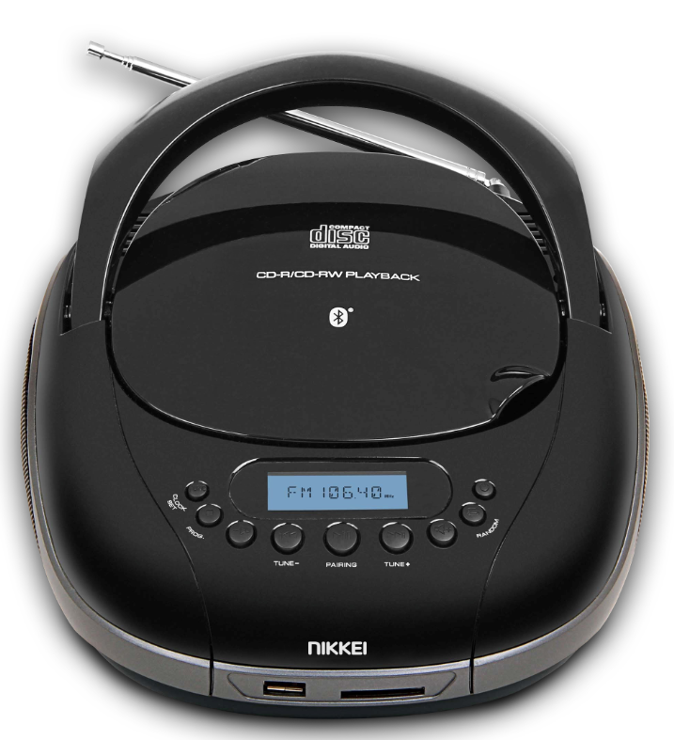

Pic ture 4: Front right perspective 40 degrees with carrying handle down, telescopic antenna up and cd door open. Also a CD must be placed (please use a blank cd for this (back side of cd))
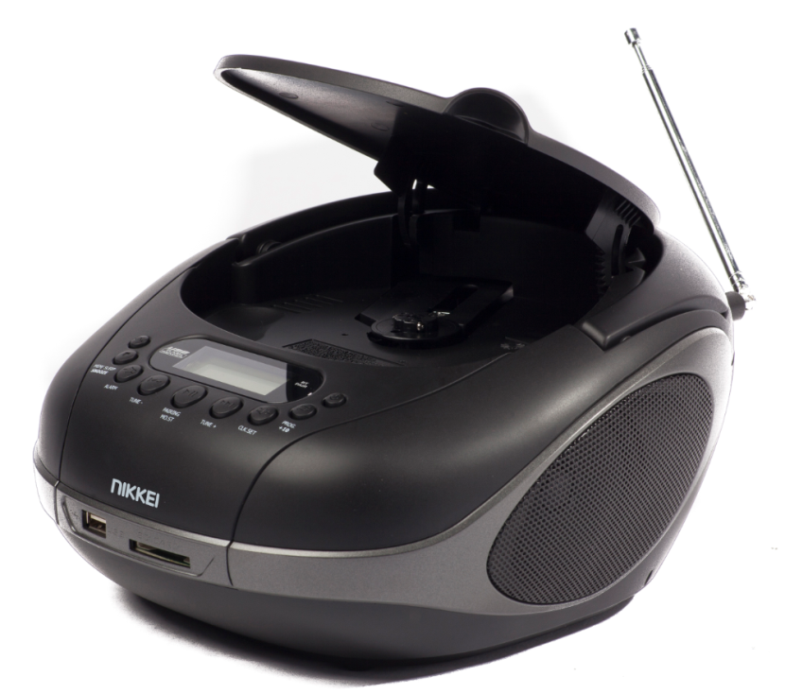
Pic ture 5: Back perspective 40 degrees with carrying handle down and antenna stowed in antenna holder. Headphone and Aux connection must show.
“No example photo available”

NPR26 Portable radio
Picture 1: Front perspective with telescopic antenna out. ( make sure every part of the antenna is out equally). Product must be on and set on a frequency
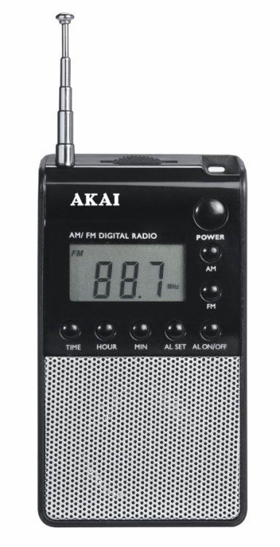
Picture 2: Front right perspective with telescopic antenna out. ( make sure every part of the antenna is out equally). Product must be on and set on a frequency. Make sure the Headphone-in port is shown.
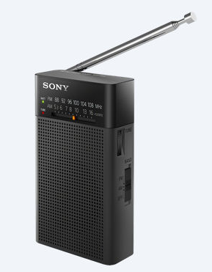
NR280P RABBIT and SHARK Kids Clockradio’s(2 products)
Picture 1: Front perspective with a set time and lights on.
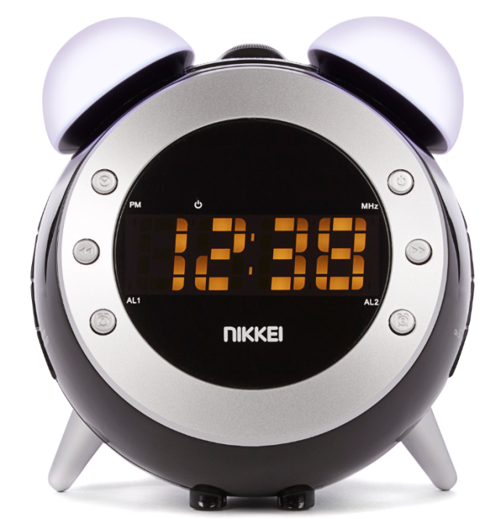
Picture 2: Front right perspective with a set time and lights off.
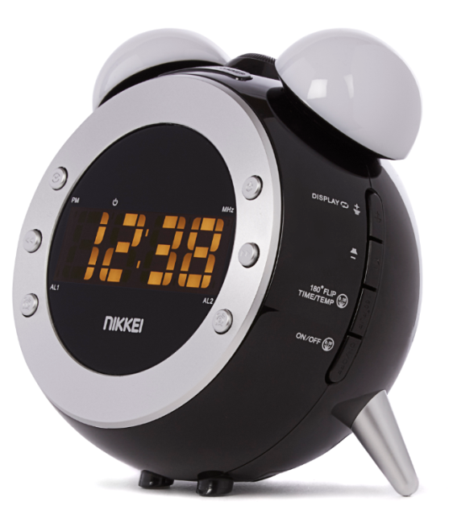

Picture 3: Front left perspective with a set time and lights off.
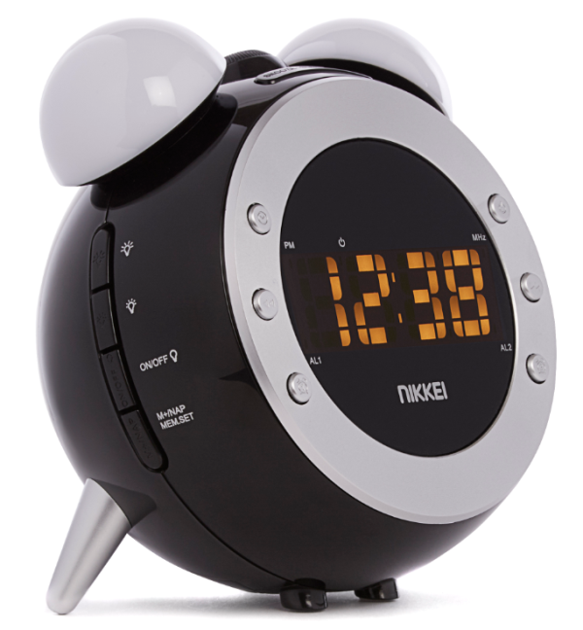

Picture 4: Top perspective with lights off
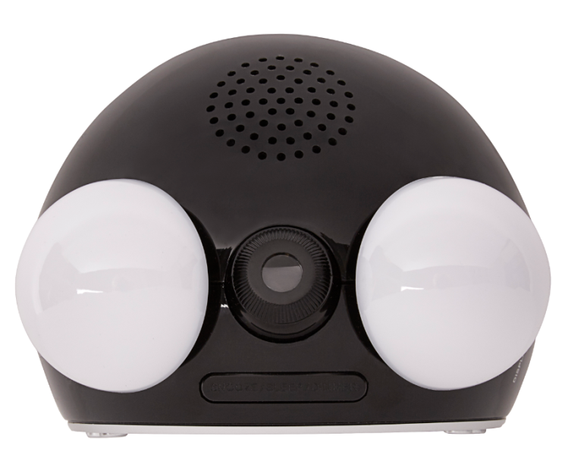

NMP4 Bluetooth MP4 players
Picture 1: Front perspective (we will photoshop the menu ourselves)
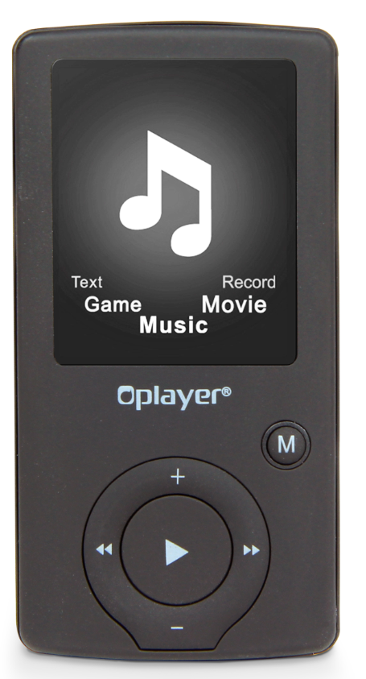
Picture 2: Front right perspective (we will photoshop the menu ourselves)
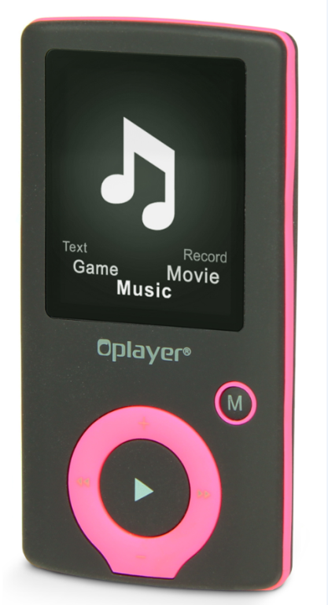

Picture 3: Player laying down ( we will photoshop the menu ourselves)
