EXTREMEX360

FYI: Basic Mount is the square Mount.

1. Front view of action cam including basic Mount (front of camera is side with blue arrow)

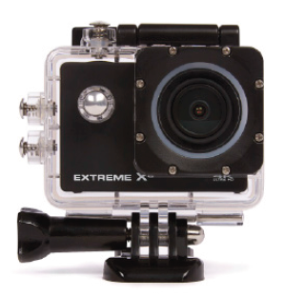

1. Rear view of action cam including basic Mount



1. Front left perspective of 40 degrees including Mount



1. Front right perspective of 40 degrees including Mount



1. Front view of only the action cam excluding the Mount



1. Top view of only the camera while display is on

**“no image available”**

1. Front left perspective of 40 degrees of only the action cam excluding the Mount



1. Front right perspective of 40 degrees of only the action cam excluding the Mount



1. Overview picture right perspective of 40 degrees with packaging contents



1. Front perspective of action cam mounted on tripod

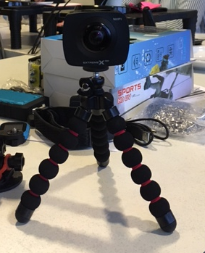

1. Side perspective of action cam mounted on tripod

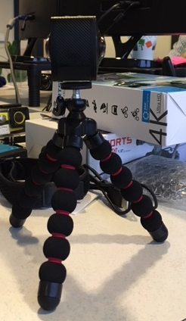

1. Total overview picture with camera mounted on round Mount , tripod next to it, adhesive tape and gopro adapter next to it.

