NRDB15 CLOCKRADIO
Picture 1: Front view 40 degrees with a set time 12:08 + set alarm and DAB playing
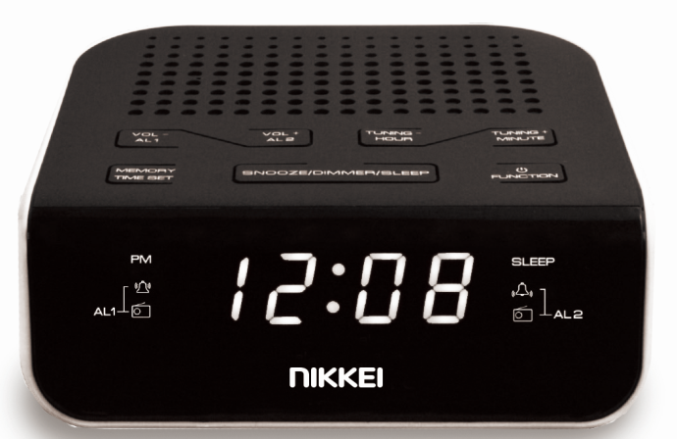

Picture 2: Front right perspective 40 degrees with a set time 12:08+ set alarm and DAB playing
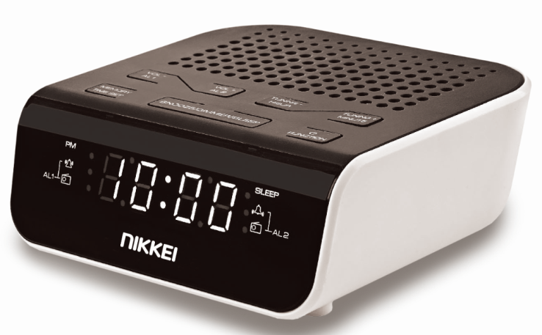

Picture 3: Front left perspective 40 degrees with a set time 12:08 + set alarm and DAB playing
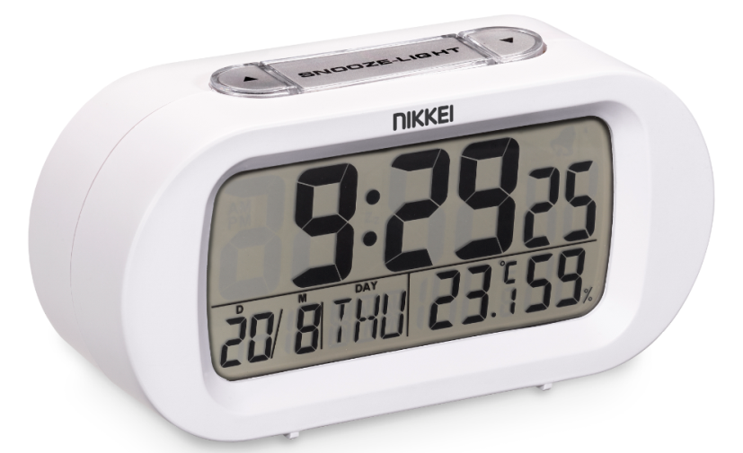

Pic ture 4: Top view with folded antenna
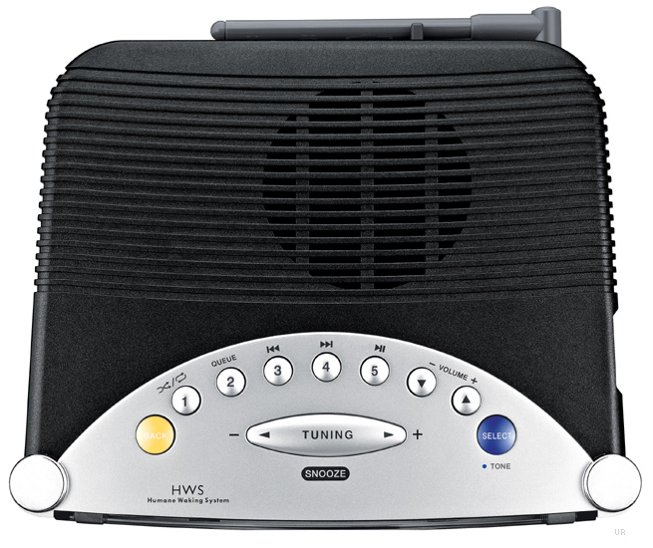

NPR450 RADIO
Picture 1: Front view 40 degrees with radio playing and alarm set
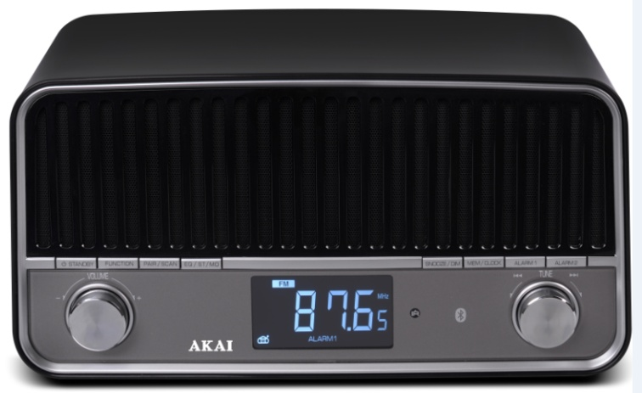

Picture 2: Front view with radio playing and alarm set
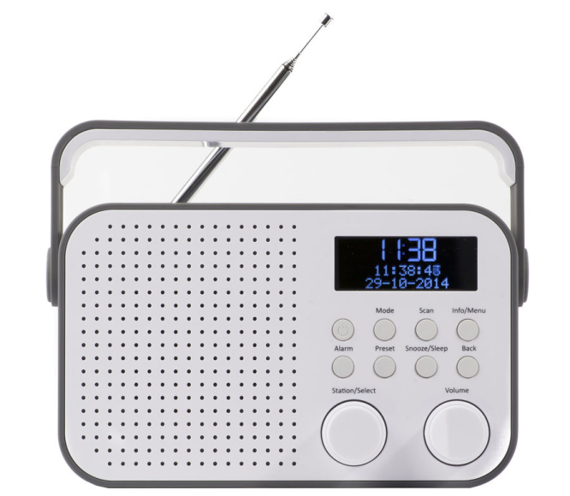

Picture 3: Front right perspective 40degrees with radio playing and alarm set
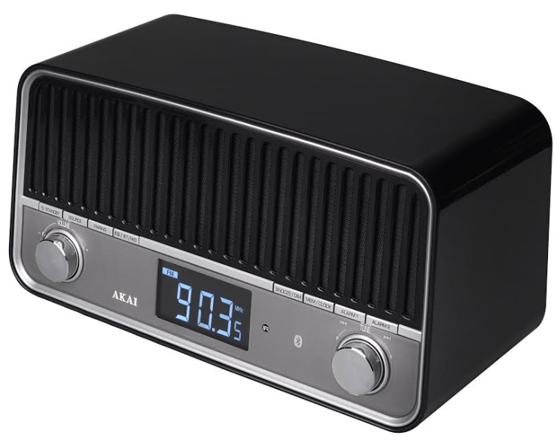
Picture 4: Front left perspective 40 degrees with radio playing and alarm set
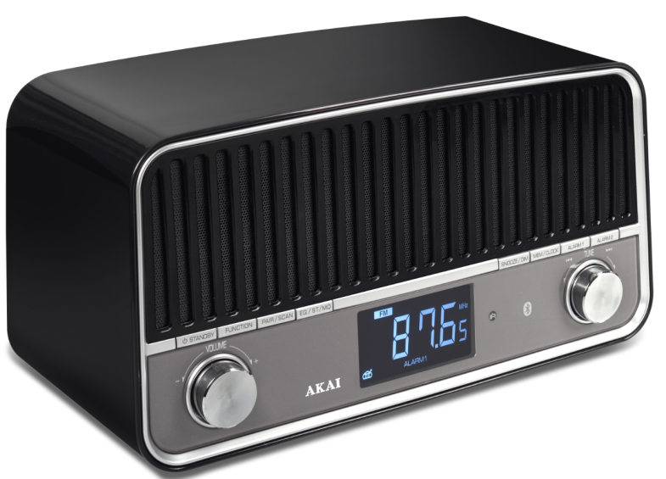
Picture 5: Back (so all connections are shown)
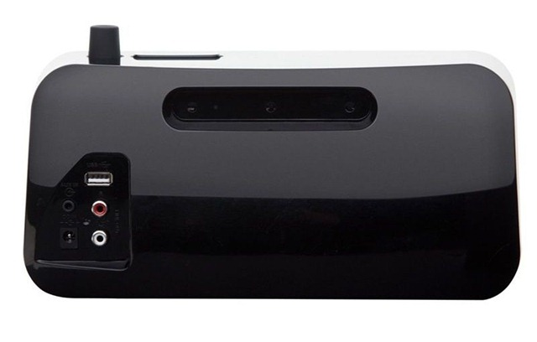
ND220H DVD-PLAYER
Picture 1: Front view 40 degrees with a DVD playing (so show active display, not 00:00)
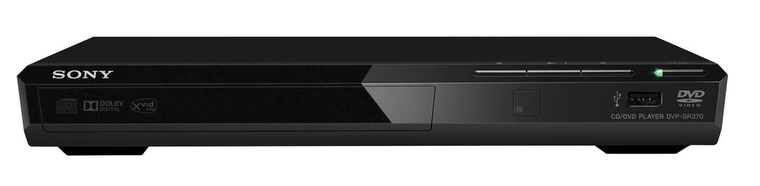
Picture 2: Front right perspective with DVD playing (so show active display, not 00:00)
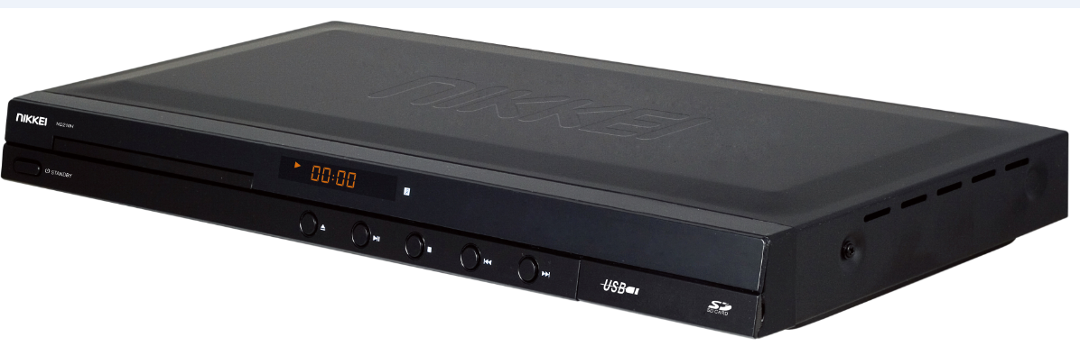

Picture 3: Front right perspective with open DVD door (and placed DVD, display shows “open”
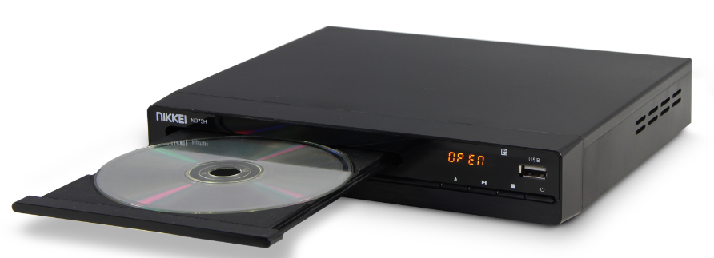

Front left perspective with DVD playing (so show active display, not 00:00)
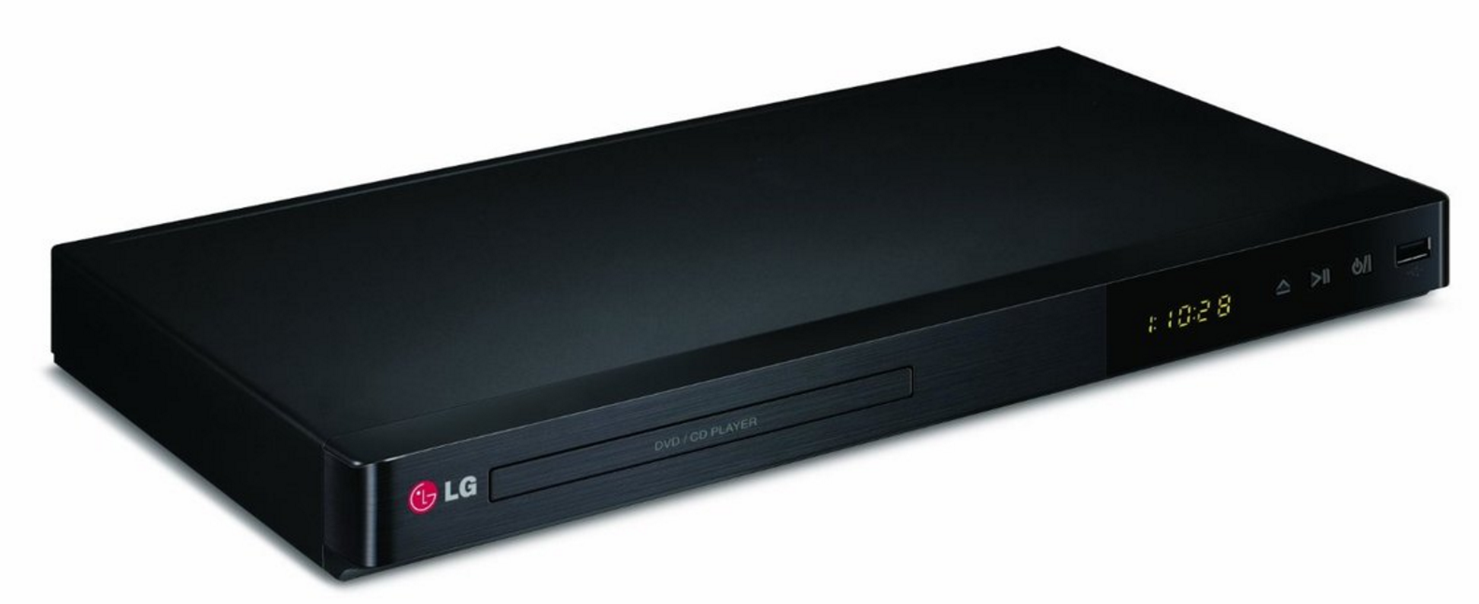
Picture 5: Back view so all the ports show
