NPRC11BK Boombox
Picture 1: Front right perspective 40 degrees with carrying handle up and telescopic antenna up. (telescope parts must be up as equal parts, not as below pictures) Display must be on.
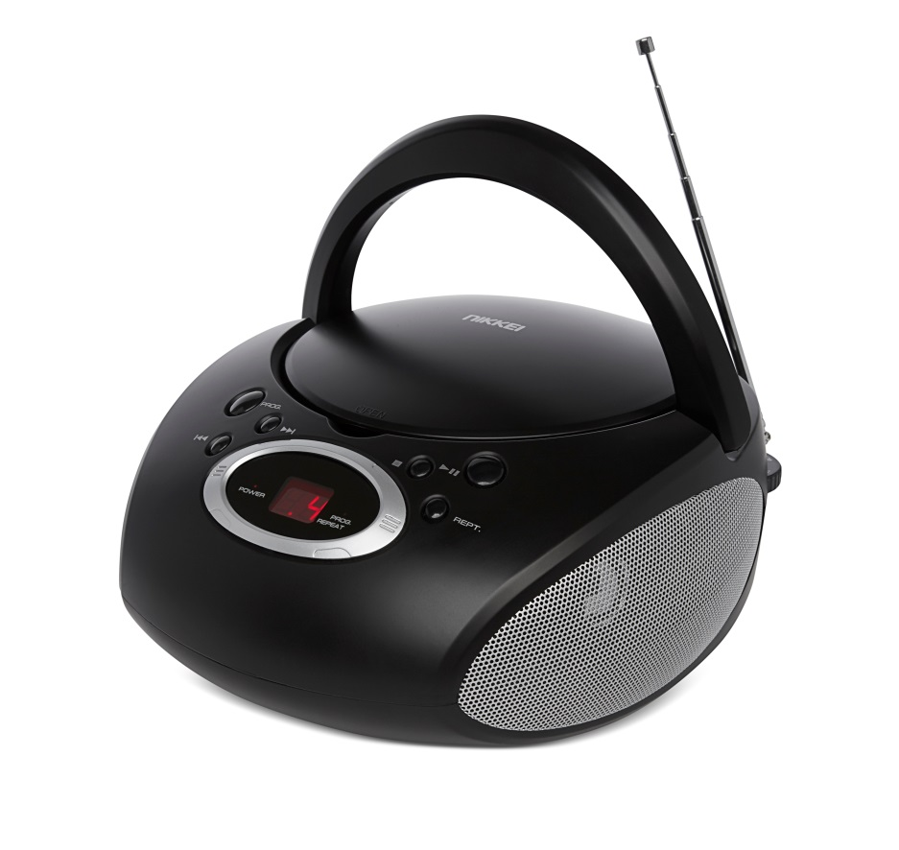

Picture 2: Front left perspective with carrying handle and antenna down. Display must be on.
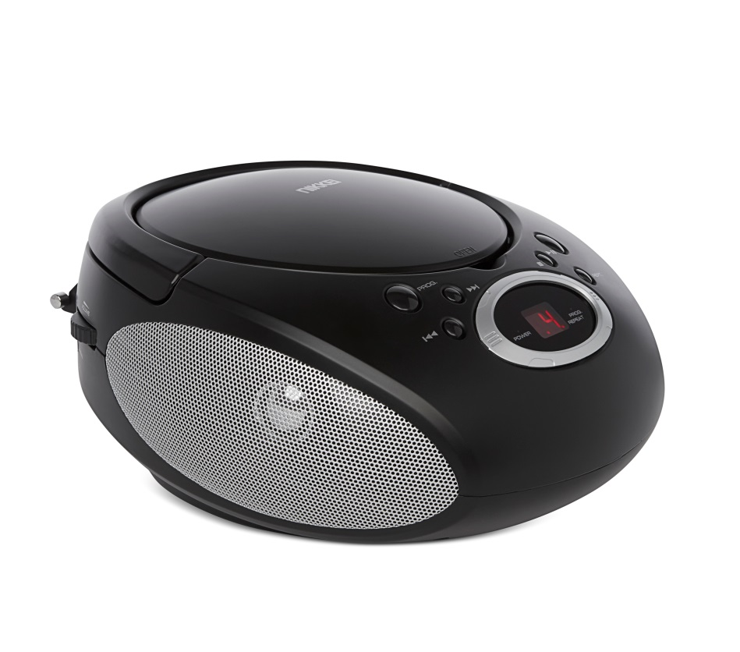
Picture 3: Front view 40 degrees with carrying handle slightly up, display on.
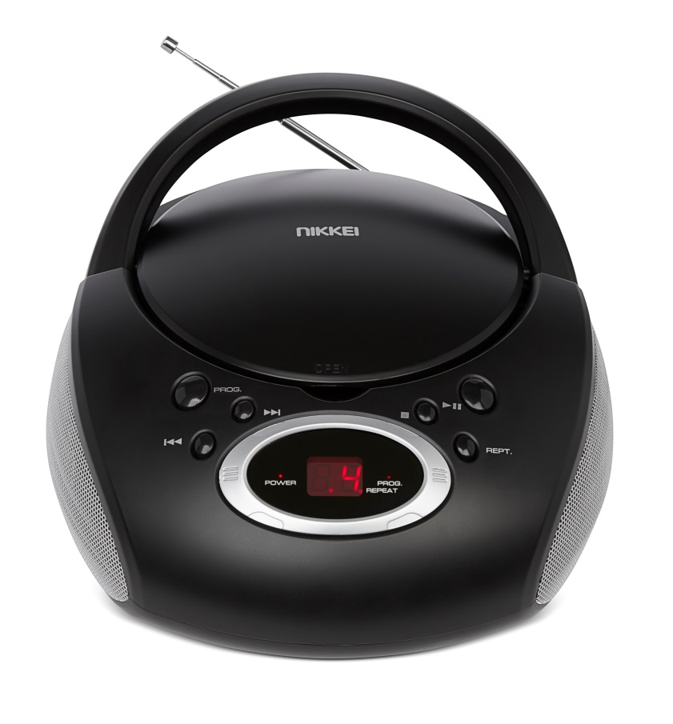

Picture 4: Front right perspective 40 degrees with carrying handle down, telescopic antenna up (telescope parts must be up as equal parts, not as below pictures) and cd door open. Also a CD must be placed (please use a blank cd for this (back side of cd))
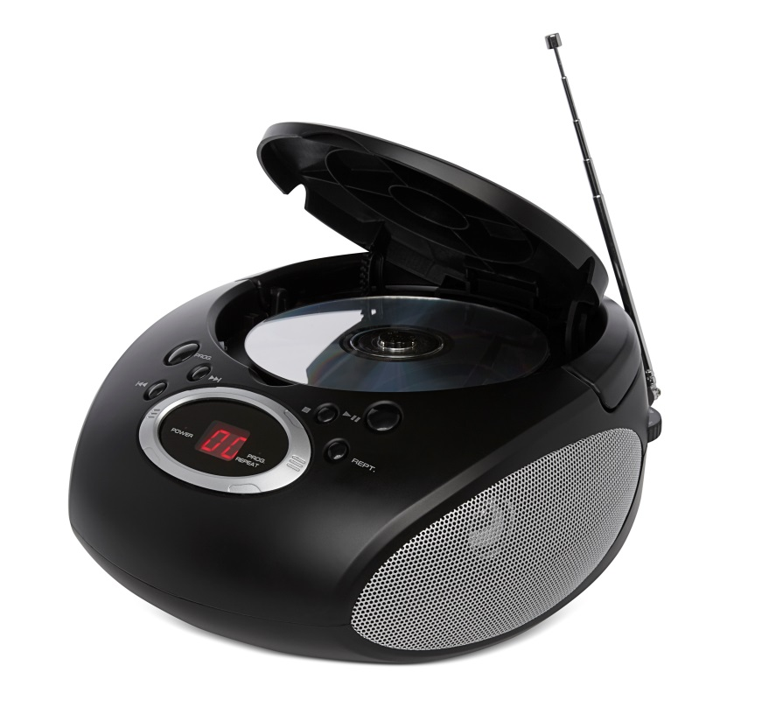
Picture 5: Back perspective 40 degrees with carrying handle down and antenna stowed in antenna holder. Manual Tuner, on/of switch, line-in connection and volume switch must show.
If it is not possible to capture all of the above in one back perspective photo then please take 2 photos; 1 from the back left perspective and 1 from the right back perspective.
