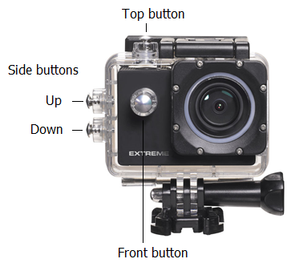

Hi Tommy,

For testing our ExtremeX6 we strongly recommend you to use the Full HD - 60FPS configurations. When you turn the camera on (Front button, camera) it is normally on 4K 30 FPS ( you can check it after turning the camera on, on the left top corner) If the setting is on 4K 30FPS you have to change the configuration.

- You have to go to configurations by tapping the front button. (if you’re not recording)
- The configuration menu has the symbol of a chain wheel, like
- In the right corner you will see the movie icon:
- You can enter the movie (icon) configuration with tapping the top button.
- You will see “Video Resolution” which you have to change. You have to tap again on the button on the top of the camera.
- Then you use the buttons on the side of the camera, you press down twice to choose “1080P 60FPS ” and select the resolution by tapping the button on the top of the camera.
- To quit the configuration menu you can exit the menu or simply shut down the camera with the Front button by holding it. After shutting down you restart the camera with the same button.

Good luck with shooting!
If you have any further questions about using the camera during the weekend. Don’t hesitate to contact me, you can find my mobile phone number below.
Kind Regards,
Michiel Huijskes
Nikkei Extreme
Phone: 0031 6 45694146

