User Manual
HEALTH FRYER 2.4L
DHFRYER
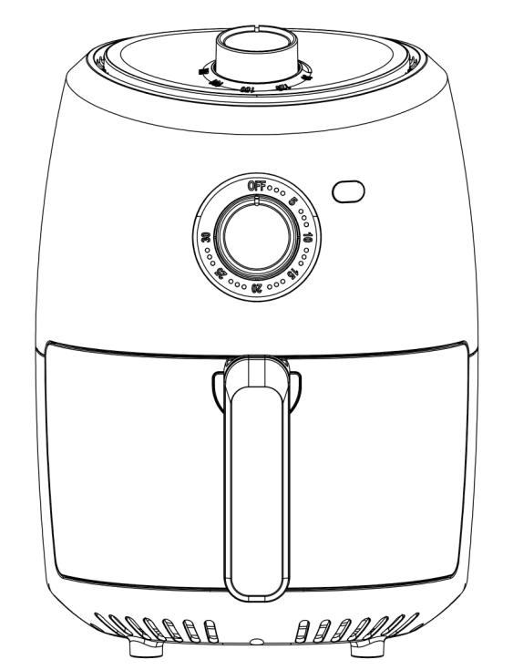

TABLE OF CONTENTS

1) Package contents
2) Safety instructions
3) Installing and using the device
4) Cleaning and maintenance
5) Product specifications
6) Storage & transportation
1) PACKAGE CONTENTS
• Health Fryer 2.4 L
• User manual

2) SAFETY INSTRUCTIONS
The following precautions must always be taken in consideration before using the “Health Fryer 2.4 L”, hereinafter referred as the “device”.

WARNING !

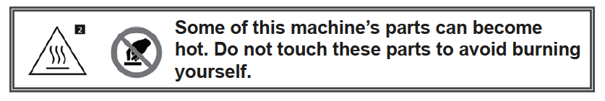
General information
• Keep the instructions safe and read carefully before use. Please also pass this manual to other body if you give this device to him
• Only use this device in accordance with the instructions in this user manual.
• This device can be used by children aged 8 and over and people with restricted physical, sensory or mental capabilities, or lack of experience and knowledge, unless they have been given supervision or instructions concerning the use of the appliance by a person responsible for their safety.
Children must not play with the device. Cleaning and maintenance must not be done by children unless they are over the age of 8 and must be under supervision.
• This device is intended for domestic or similar use, not for professional use.

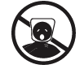
• WARNING! The packaging material is not a toy and do not leave packagingit lying around carelessly. This may become dangerous playing material for children. Risk of suffocation!

Electricity and heat
• Before use, check that the mains voltage is the same as the mains voltage stated on the rating plate of the device.
• Make sure your hands are dry before touching the device, power cord or plug.
• Plug the power plug into an electrical outlet with earthing that is easily accessible at all times.
• WARNING! Never cover the power plug or cable with cloths, curtains or any other material to prevent overheating and potential fire hazards.

• Make sure that the device and power cable do not come into contact with heat sources, like a naked flame or hot hob.
• The device must be able to dispel its heat in order to prevent the risk of fire. Make sure there is sufficient free space around the device (at least 15 cm from all sides) and do not place the device in contact with combustible materials and/or on or near combustible materials.
• WARNING! The device and/or the air inlet and/or air outlet must not be covered, in order to prevent overheating and potential fire hazards.
• Regularly check the power cord for damage.
• Never use the device if the power cord shows signs of damage, if the device has fallen on the ground or shows any other signs of damage.
• Switch OFF the device and remove the power plug if you discover any problems or faults during use, find any signs of damage, are not using the device or are cleaning it.
• Make sure the power cord cannot be trodden on or pinched.
• Do not allow the power cord to hang over sharp edges and keep it away from hot objects and naked flames.
• When plugging in the power plug, make sure people cannot pull it out or trip over it accidentally.
• Remove the power plug from the power socket during lightning storms or if unused for long periods of time.
• Use a 10-amp cable if an extension cable is required. Cables with a lower amp rating may burn out.
• When using an extension cable, make sure it is completely extended.
• WARNING! To reduce the risk of fire or electric shock, protect the
device from dripping or splashing water and keep away from objects
filled with liquids, such as vases. These objects should not be placed
on or near the device.

Use
• Do not use the device in the vicinity of flammable materials.
• Do not leave the device unattended when it is in use.
• Never move the device when it is switched ON or still warm. First switch OFF the device and only move it once it has cooled down.
• Only use tools featuring a handle that is well insulated against heat, or use the tong while wearing oven gloves.
• Do not use sharp objects in the inner basket. These damage the non-stick coating.
• Do not spill hot oil on the heating element. This will create smoke and cause unpleasant smells.
• Clean the device thoroughly after use (see “cleaning and maintenance”).
• It is advisable to place a heat -resistant covering between the table or sink counter and the device, to prevent the heat leaving marks on your table or worktop.
• Avoid locations subject to vibrations, cold or humidity.
• Do not expose the device to heat sources, direct sunlight, excessive humidity or corrosive environments.
• Do not place the device under any mechanical stress.
• Improper use of the device could damage the product.
• Please handle the device carefully. Impacts or falls, even from a low height, can damage the device.
• Do not open the casing as this may result in electric shock.
• Do not attempt to disassemble or repair the device or modify it in any manner.
• The device must be serviced if it has been damaged in any way, i.e. the power supply cord/plug is damaged;
liquid has been spilled; objects have fallen into it; it has been exposed to rain or moisture; it has been dropped or does not operate properly.
• Do not use abrasive cleaning solvents to clean the device.
• Do not use foreign objects to clean the device.
• When the device is working, hot air is released via the air outlet, and users should therefore keep a safe distance from the outlet for safety.

Important information, follow these instructions

• This device can be used by children aged 8 and over and people with restricted physical, sensory or mental capacity or a lack of experience and expertise, provided they are under supervision or have been given
instructions about safely using the device and are aware of the potential hazards. Children must not play with the device. Cleaning and maintenance must not be done by children unless they are over the age of 8 and
under supervision.
• Only use the device indoors, in dry areas and not in the vicinity of water, other liquids or humidity.
• Do not use the device if it, the cable or power plug has fallen into water or any kind of fluid.
• Never immerse the device, cable and power plug in water or any kind of fluid.
• Do not pick up the device if it has fallen into water or any kind of fluid. Remove the plug from the power socket immediately. Do not use the device again.
• Place the device on a flat and stable surface, in a place where it cannot fall over.
• Do not switch ON the device until all of the accessories have been properly installed and make sure the lid is closed before you plug the device into the mains and switch it ON.
• Parts of the device can become hot. Do not touch these parts to avoid burning yourself.
• Only hold the frying basket by its plastic handles. The metal section with which the handles are attached to the inner basket can become very hot.
• Never use or fill the frying basket with oil; this may cause a fire hazard!
• The device is equipped with an overheating safety feature. This is activated if the temperature becomes too high. If this is the case, you must let the device cool down before it can be used again. Switch OFF the device and then remove the plug from the power socket. Allow the device to fully cool down. The device needs approximately 30 minutes to fully cool down.
• Remove the power plug from the power socket if the device is unused for long periods of time.
• When removing the plug from the power socket, pull the plug itself, not the cable.
• Do not operate the device using an external time switch or a separate remote control system.

3) INSTALLING AND USING THE DEVICE

Open the packaging carefully before taking out the device. Make sure the device is complete and undamaged.
If any components are missing or damaged, contact the vendor and do not use the product. Retain the packaging or recycle it in accordance with local regulations.

Parts & features device
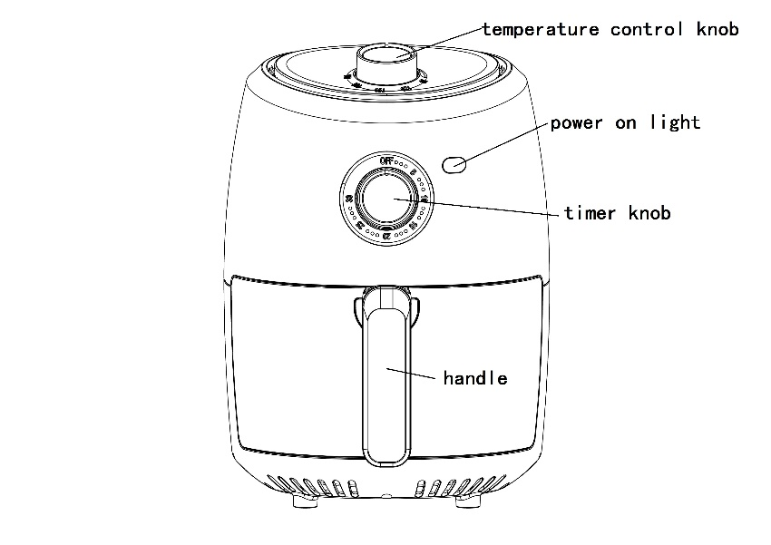

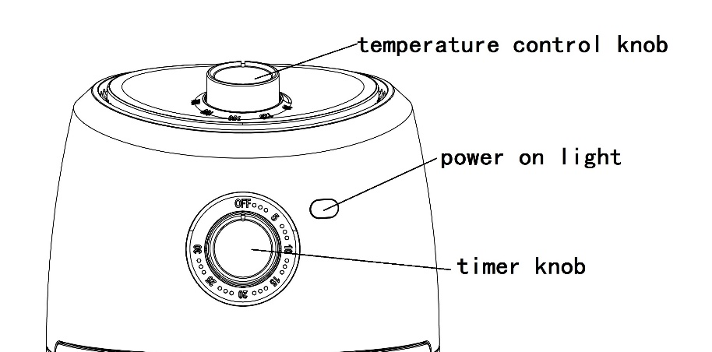

Notice:
1) The timer knob indicates 0-30 minutes, and the max time is 30 minutes.
2) The temperature control knob indicates (OFF) and 90-200 degrees, and the max. temp. is 200 degree
3) The direction adjustment is the same for the time and temp knob, turning in clockwise direction will set timer longer/temperature higher

To power on the device, turn the timer knob to the desired cooking time. Once to timer is set, the power LED indicator lights up.
When the timer reaches its set time, you will hear a bell, and the device will automatically switch off and the power LED indicator will no longer light up.
To manually switch off the device, turn the timer knob to 0 until you hear a bell, the power LED indicator will no longer light up.

First use:
• Remove the device and accessories from the box. Remove any stickers, protective film or plastic from the device.
• Before you use the device for the first time, wipe all the removable parts with a damp cloth. Never use aggressive or abrasive cleaning materials, a scouring sponge or steel wool; this damages the device, the interior and the frying basket.
• Place the device on a flat, stable surface, in a place where it cannot fall over.
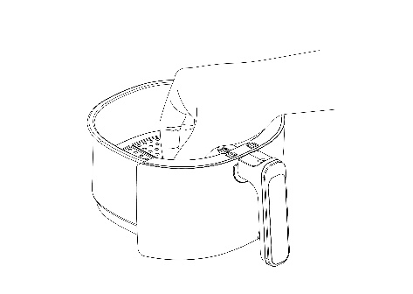
• Use the handle to remove the frying basket. Properly place the crisp plate into the frying basket.
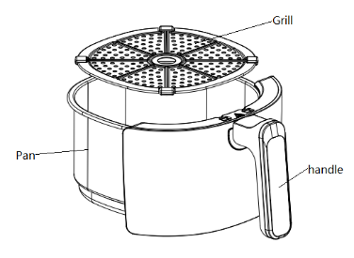

• Connect the power plug to the mains power.
• Allow the device to warm up for 15 minutes without any food inside it, by turning the timer knob to 15.

• You will encounter a small amount of smoke and a specific smell the
First time you use the device. This is normal and will soon
disappear。Make sure there is adequate ventilation.

Cooking / Frying
• Place the device on a flat, stable surface, in a place where it cannot fall over.
• PRE-HEATING: Set the time to 3 minutes; to start the pre-heating session and allow the device to warm up.
• After pre-heating, use the handle to remove the frying basket from the device and place it on a stable,
horizontal and flat surface.
• Caution: The device and frying basket will be hot. Handle
carefully to avoid injury.

• Place foodstuffs into the frying basket. Caution: Never fill the frying basket above the “MAX” indicator.
• Do not fill the frying basket with oil or other liquids.
• Insert the frying basket back into the device until you hear a click.
• Set the desired cooking time using the timer knob to start the cooking process.
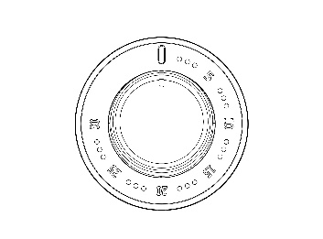

• Turn the temperature control knob to the required temperature
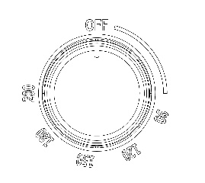

• The device will start to operate and will stop automatically when the timer reaches 0.

• Pull the basket out of the appliance.
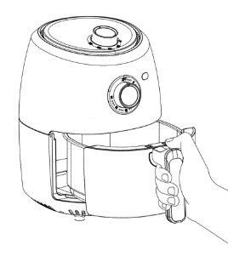

• It is recommended to occasionally remove the frying basket during cooking, so food items can be shaken. This means all items will be evenly browned on all sides. Once the frying basket is removed from the device, the device stops working and the power LED indicator switches off. When the frying basket is placed back, the device continues the cooking process for the remaining time.
• Caution: Prevent burn injuries. Do not touch the frying
basket; it is very hot. When removing the frying basket, use a heatproof stand or coaster and kitchen gloves for extra support.
• Use the handle to remove the frying basket from the device and place the frying basket on a stable, horizontal, flat heat-resistant surface.
• Remove the food from the frying basket and place it on a plate or dish.
• Caution: Prevent burn injuries. Do not touch the frying.
basket; it is very hot. When removing ingredients (e.g. beef, chicken, meat or other ingredients with original oil or juices), excess oil or juices will have collected at the bottom of the frying basket. DO NOT turn the basket over, otherwise oil or juices collected at the bottom of the frying basket will leak onto the ingredient or leak out onto the surface. Please use tongs to pick up these ingredients one by one in order to prevent hot oil or juice spillages and possible burn injuries.
• Do not use metal items to remove food from the frying basket. This prevents the non-stick coating from being damaged.
• Excess food residues, oil and liquids are collected in the bottom of the frying basket. They must be removed immediately after use, so they do not remain until the device is next used.
• Switch OFF the device if you are not going to continue using it and remove the plug from the power socket.

4) CLEANING AND MAINTENANCE

• Clean the frying basket and device after use.
• Remove the plug E from the power socket and allow the device to fully cool down (± 30 minutes).
• Never immerse the device in water or any other liquid.
• Clean the device after each use.
• Clean the casing and insides with a damp cloth and perhaps a bit of v up liquid.
• First wipe the fryer and basket with a soft cloth or kitchen towel; then clean with a plastic washing-up brush in warm water and washing-up liquid.
• Never use aggressive or abrasive cleaning materials, a scouring sponge or steel wool; these damages the device, and will scratch and damage the non-stick materials.
• Dry the basket, fryer and base thoroughly.
• Re-assemble the device so the basket is back inside the device.
• DO NOT store any metal accessories inside the basket, you will damage the non-stick coating.
• Store the device in a dry place.
• • Only the basket and crisp plate may be washed in the dishwasher,
however for optimum service life of the non-stick layers and to avoid possible discoloration of the materials, we recommend to hand wash these
parts in warm soapy water.
If the non-stick coating has been damaged by abrasion with the accessories, do not wash in the dishwasher as this will only exacerbate the problem. can be washed in the dishwasher.

5) SPECIFICATIONS

• Voltage input: 220-240 V~, 50/60 Hz, Class I
• Power: 1000 W
• Temperature range: 90°C - 200 °C
• Timer range: 1-30 min
• Capacity: 2.4 L
• Dimensions: 30.5 x 20.5 x 26 (H x W x D)
• Weight: 2.6 kg.

6) STORAGE & TRANSPORTATION

• When storing the device, it should first be cleaned in accordance with this user manual. The device should be stored in its original packaging.
• Always store the device in a dry and well-ventilated room and beyond the reach of children.
• Protect the device against vibrations and shocks during transport.

All contents and specifications mentioned in this manual are subject to change without prior notice.

